**Class:** Final Year (Computer Science and Engineering)

**Year:** 2022-23 **Semester:** 1

**Course:** High Performance Computing Lab

**Practical No. 9**

**Exam Seat No: 2019BTECS00064**

**Name – Kunal Santosh Kadam**

**Problem Statement 1:**

Implement Vector-Vector addition using CUDA C. State and justify the speedup using different size of threads and blocks.

**Screenshot #:**

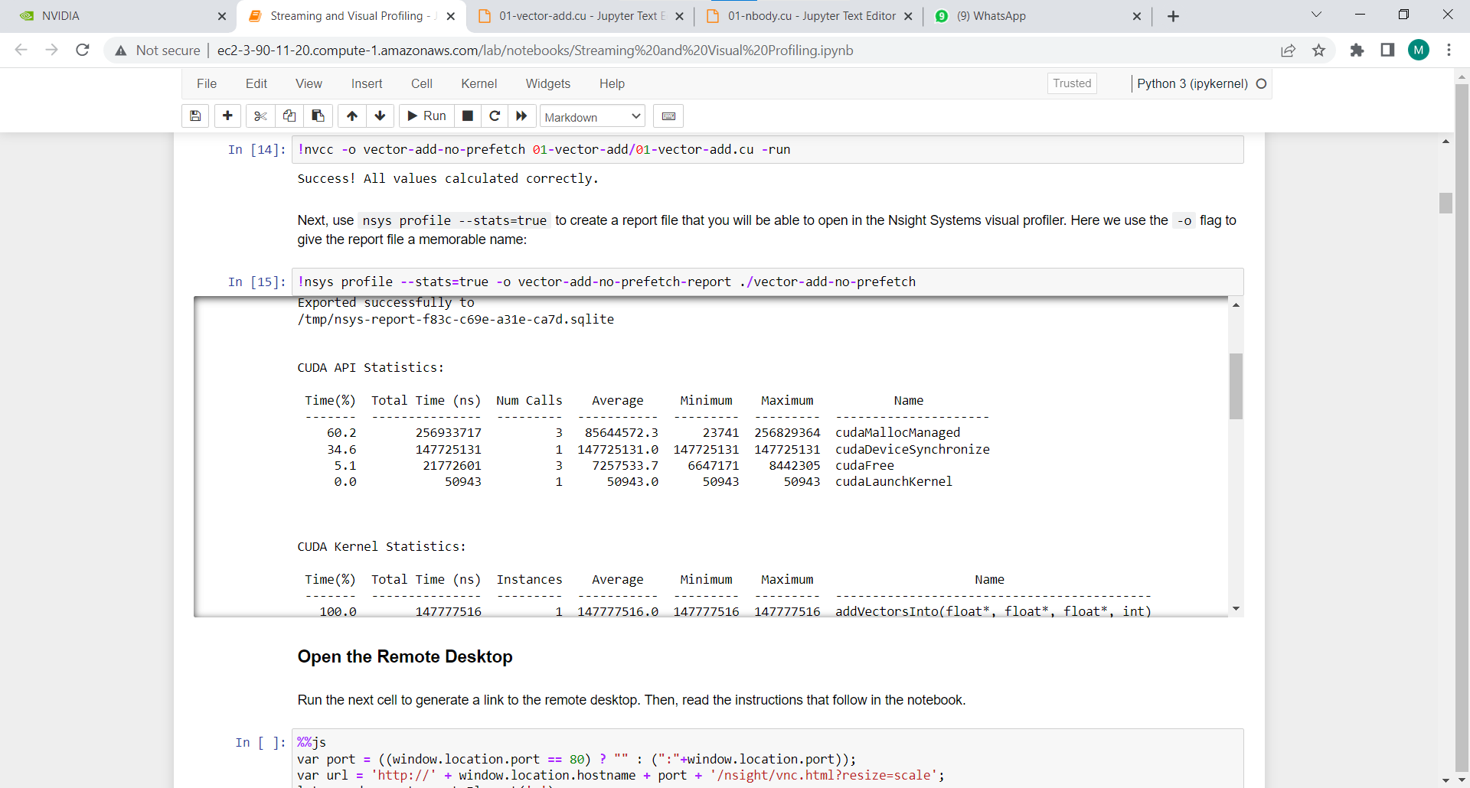

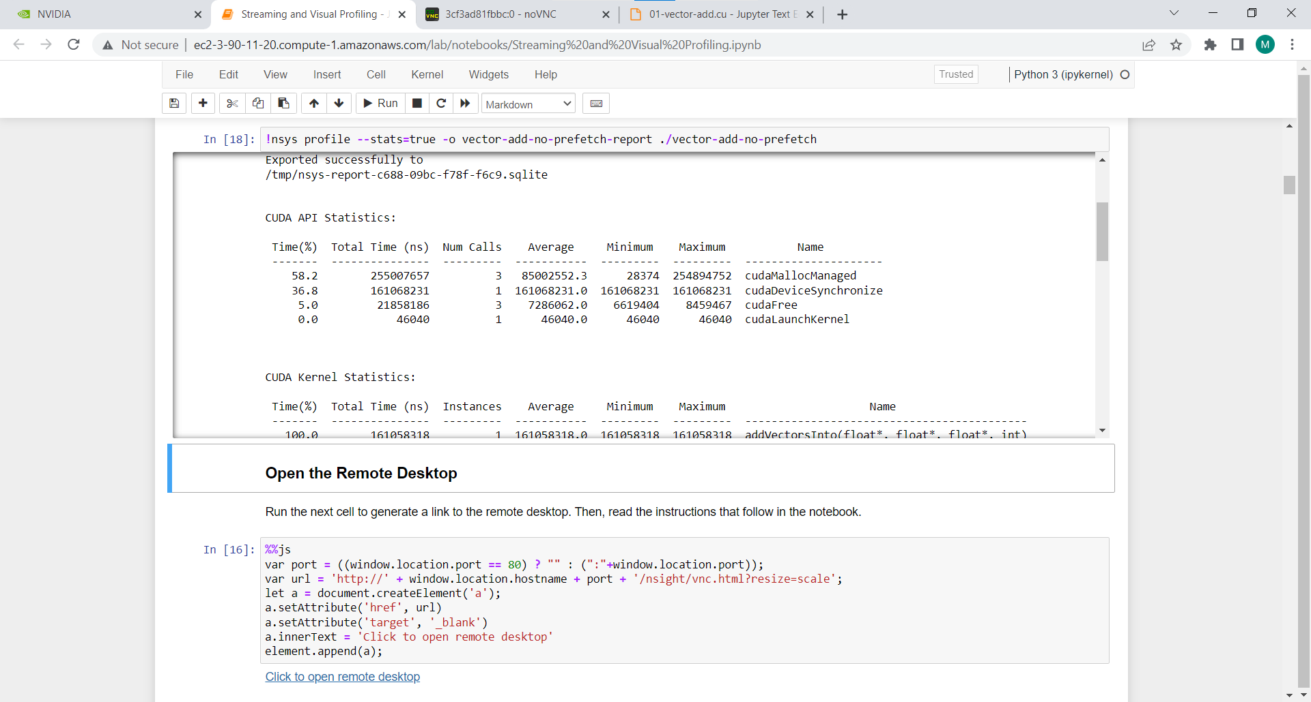

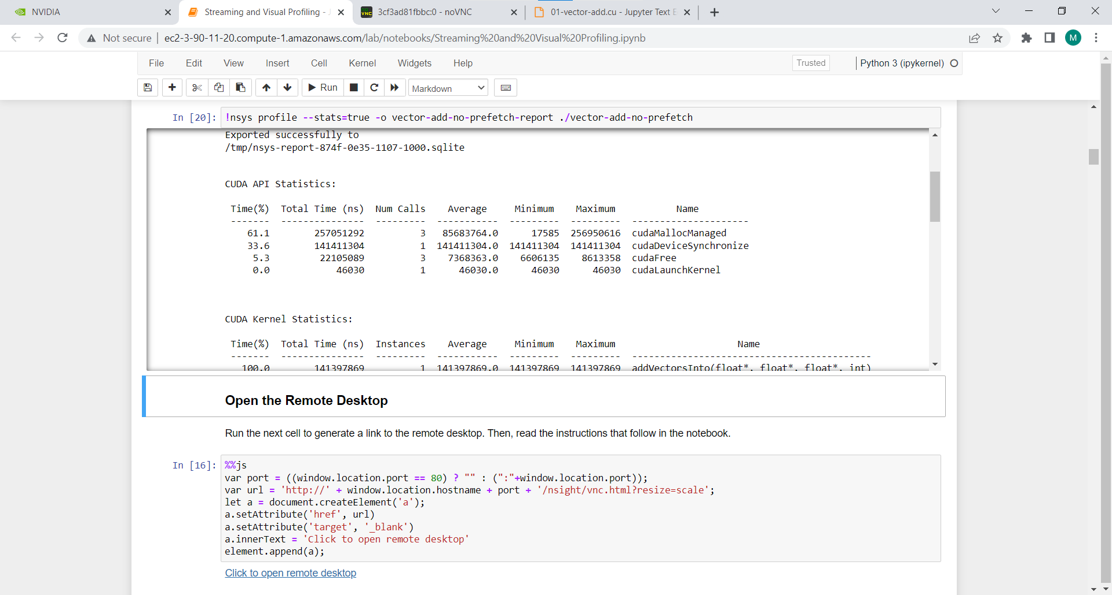

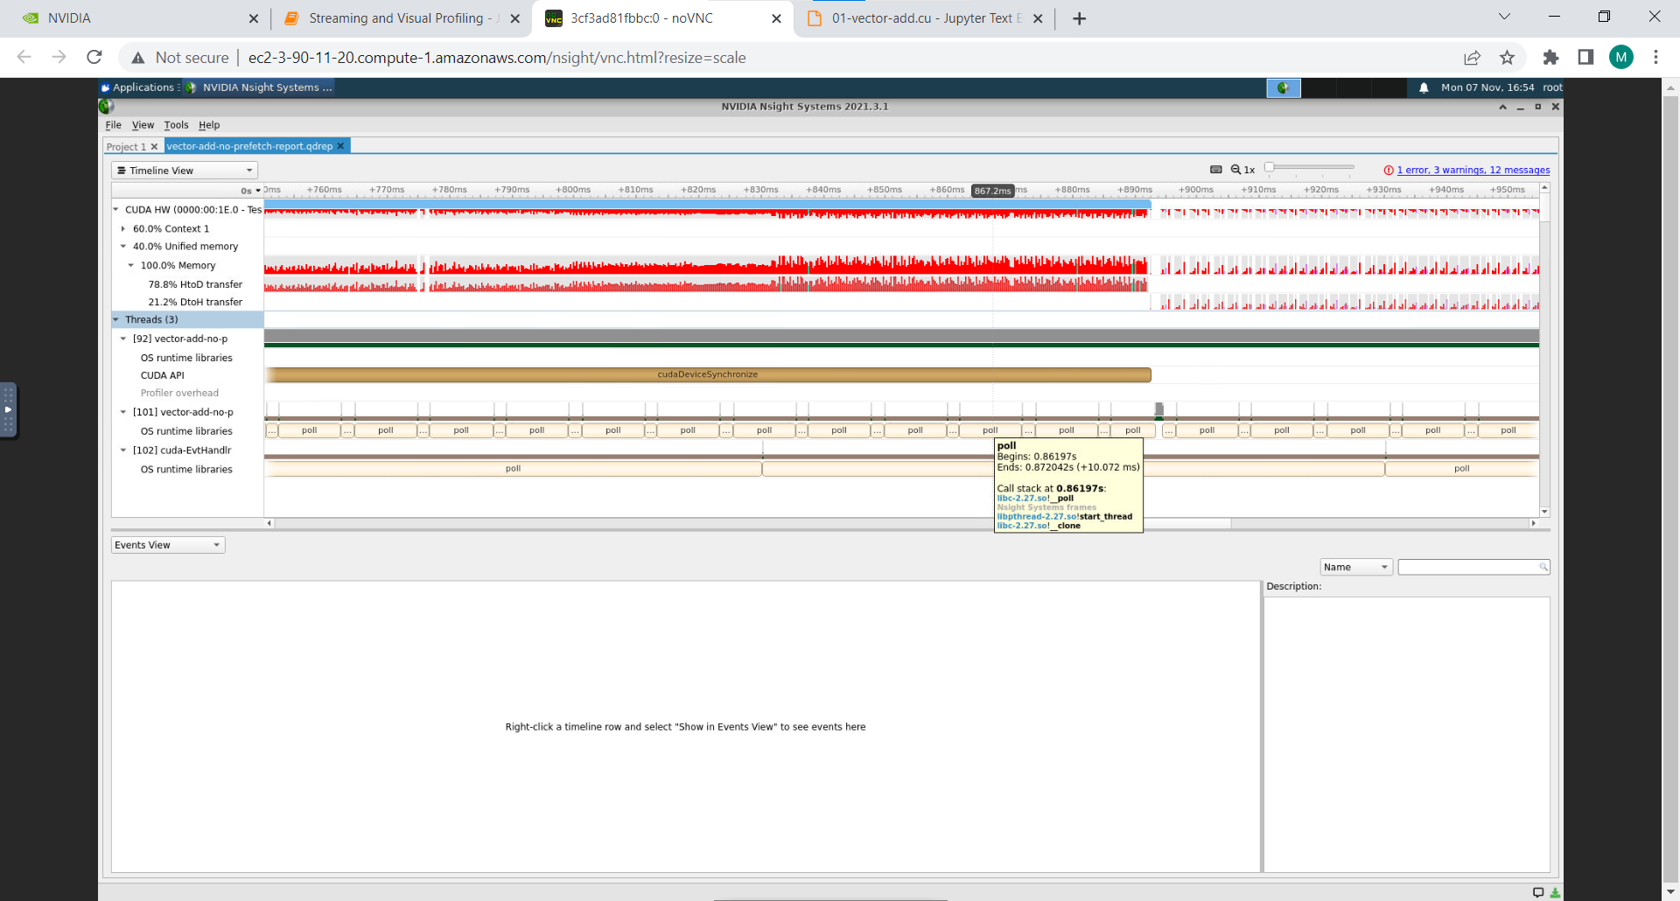

**Information #:**

#include <stdio.h>

void initWith(float num, float *a, int N)

{

for(int i = 0; i < N; ++i)

{

a[i] = num;

}

}

__global__ void addVectorsInto(float *result, float *a, float *b, int N)

{

int index = threadIdx.x + blockIdx.x * blockDim.x;

int stride = blockDim.x * gridDim.x;

for(int i = index; i < N; i += stride)

{

result[i] = a[i] + b[i];

}

}

void checkElementsAre(float target, float *vector, int N)

{

for(int i = 0; i < N; i++)

{

if(vector[i] != target)

{

printf("FAIL: vector[%d] - %0.0f does not equal %0.0f\n", i, vector[i], target);

exit(1);

}

}

printf("Success! All values calculated correctly.\n");

}

int main()

{

int deviceId;

int numberOfSMs;

cudaGetDevice(&deviceId);

cudaDeviceGetAttribute(&numberOfSMs, cudaDevAttrMultiProcessorCount, deviceId);

const int N = 2<<24;

size_t size = N * sizeof(float);

float *a;

float *b;

float *c;

cudaMallocManaged(&a, size);

cudaMallocManaged(&b, size);

cudaMallocManaged(&c, size);

initWith(3, a, N);

initWith(4, b, N);

initWith(0, c, N);

size_t threadsPerBlock;

size_t numberOfBlocks;

threadsPerBlock = 256;

numberOfBlocks = 32 * numberOfSMs;

cudaError_t addVectorsErr;

cudaError_t asyncErr;

addVectorsInto<<<numberOfBlocks, threadsPerBlock>>>(c, a, b, N);

addVectorsErr = cudaGetLastError();

if(addVectorsErr != cudaSuccess) printf("Error: %s\n", cudaGetErrorString(addVectorsErr));

asyncErr = cudaDeviceSynchronize();

if(asyncErr != cudaSuccess) printf("Error: %s\n", cudaGetErrorString(asyncErr));

checkElementsAre(7, c, N);

cudaFree(a);

cudaFree(b);

cudaFree(c);

}

**Problem Statement 2:**

Implement N-Body Simulator using CUDA C. State and justify the speedup using different size of threads and blocks.

**Screenshot #:**

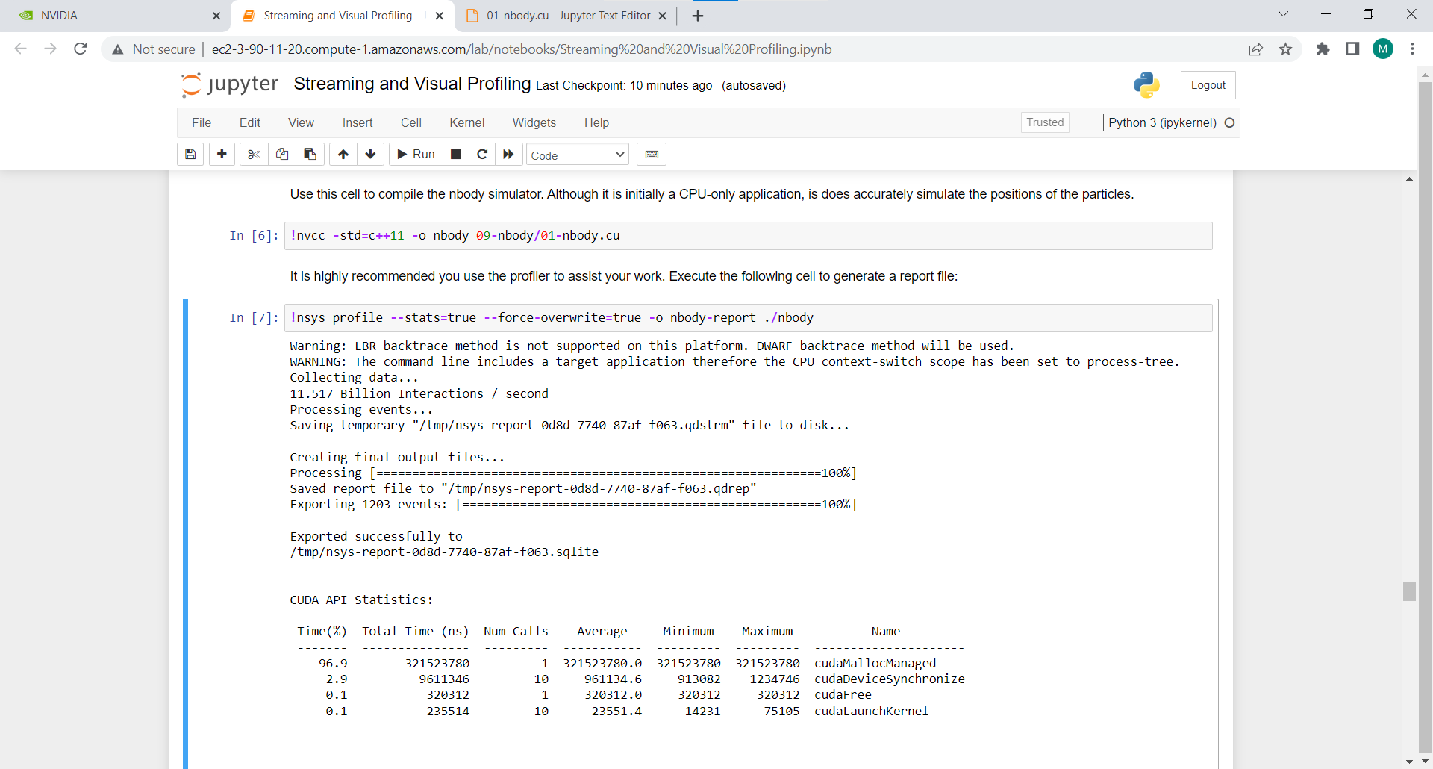

Number of thread per block – 32 with block size 1024

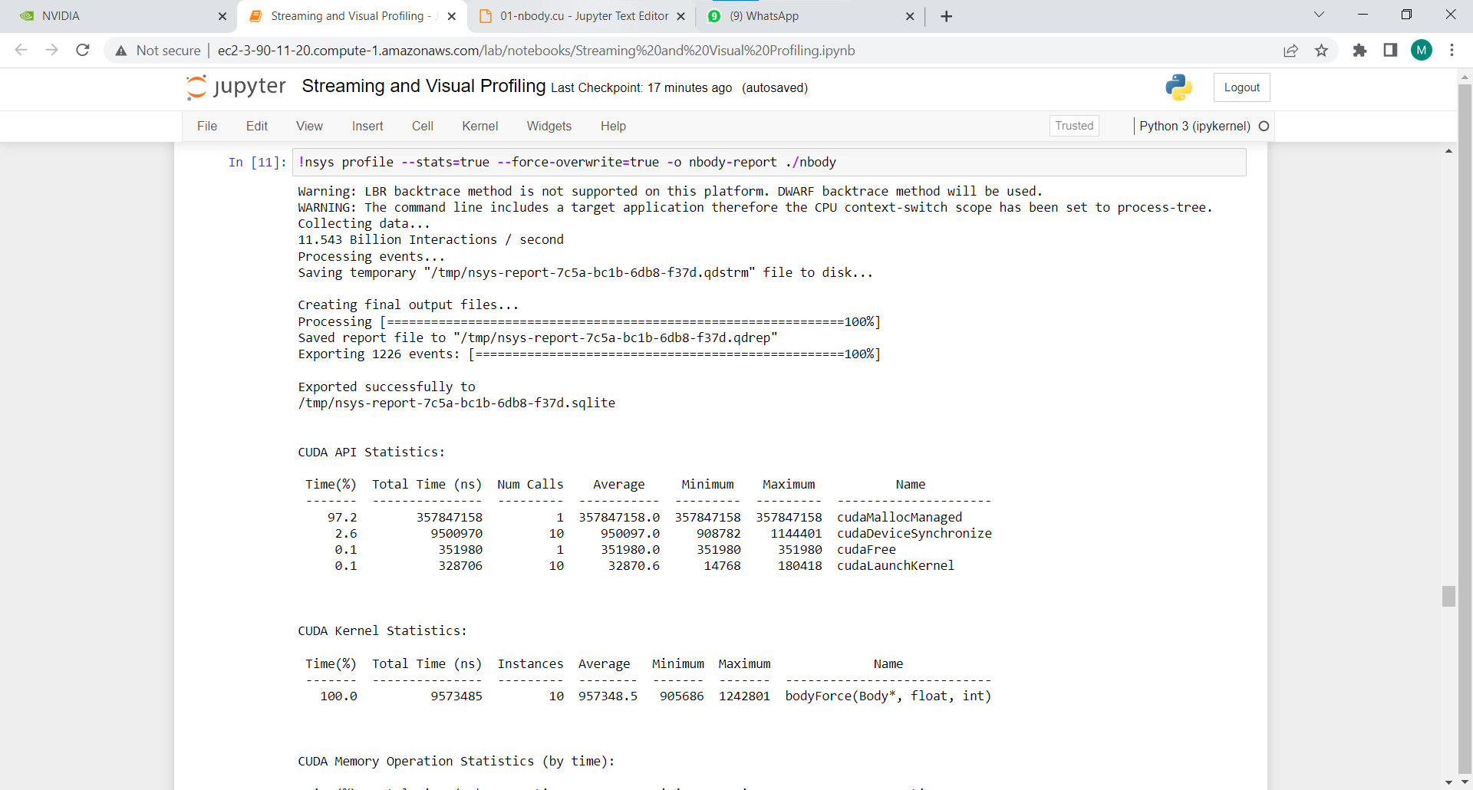

Number of thread per block – 32 with block size 512

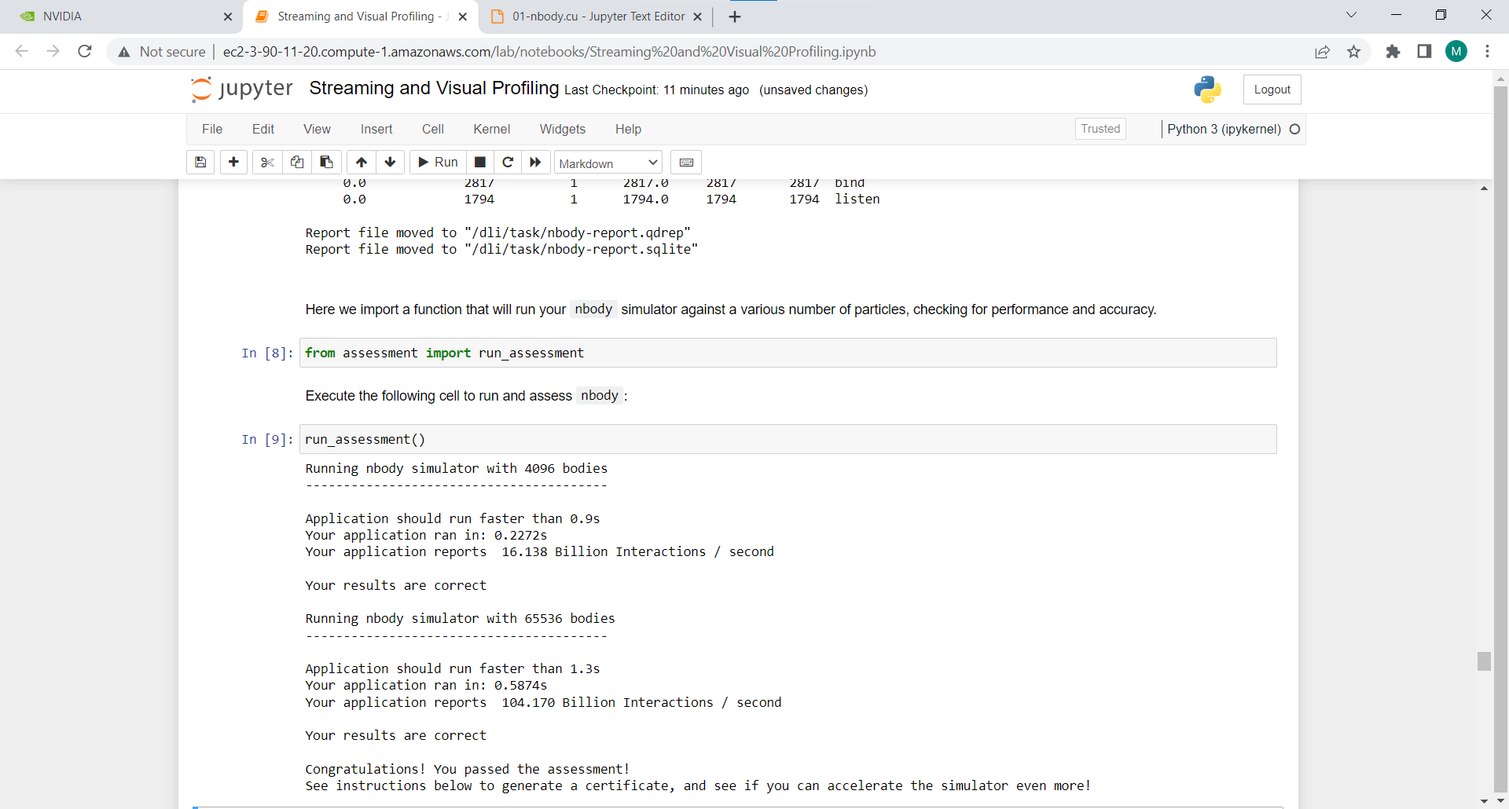

Number of thread per block – 4 with block size 1024

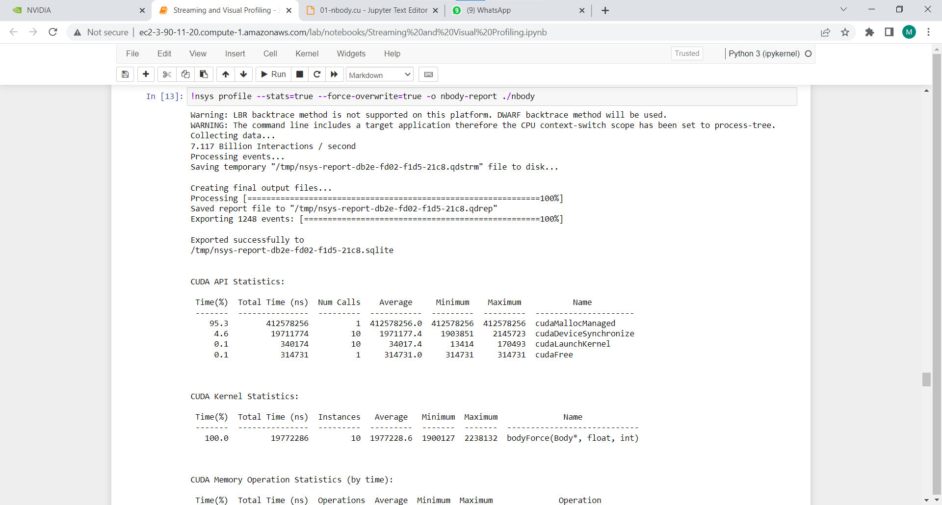

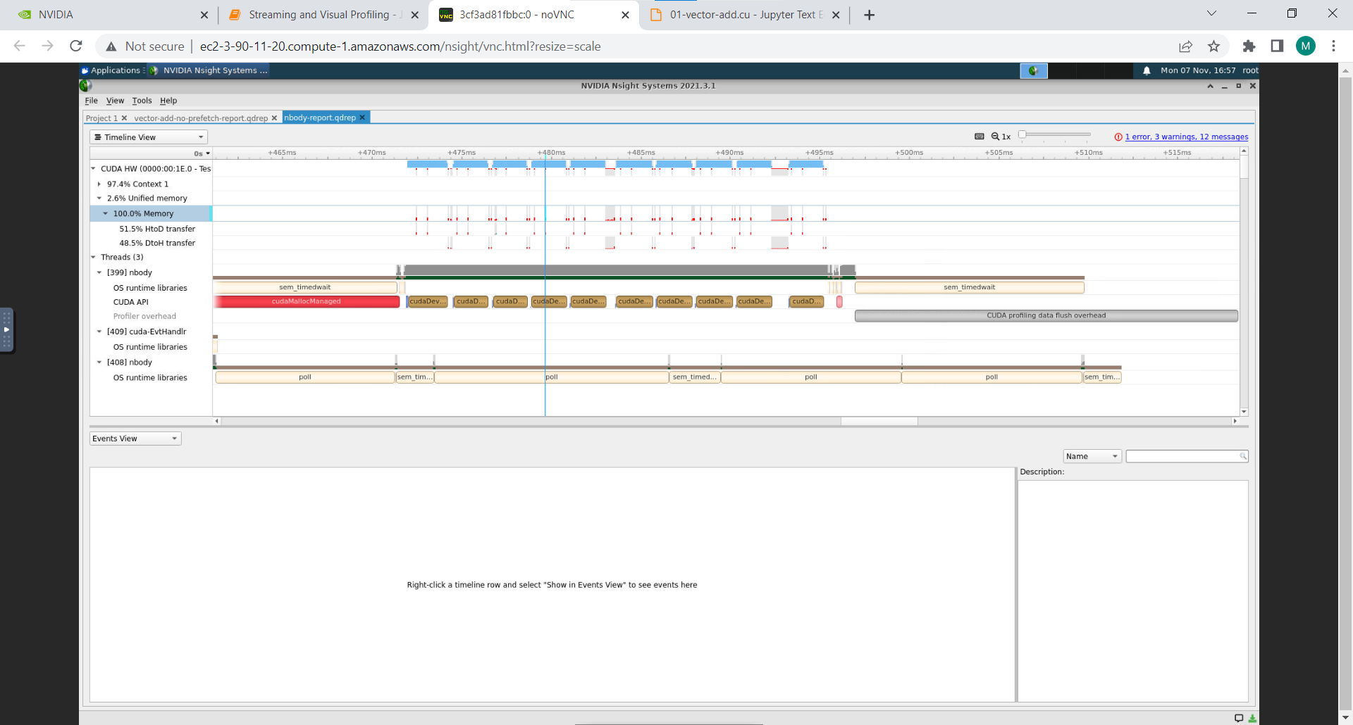

**Information #:**

#include <math.h>

#include <stdio.h>

#include <stdlib.h>

#include "timer.h"

#include "files.h"

#define SOFTENING 1e-9f

typedef struct { float x, y, z, vx, vy, vz; } Body;

__global__ void bodyForce(Body *p, float dt, int n)

{

int index = threadIdx.x + blockIdx.x * blockDim.x;

int stride = blockDim.x * gridDim.x;

for(int i = index; i < N; i += stride)

{

float Fx = 0.0f; float Fy = 0.0f; float Fz = 0.0f;

for (int j = 0; j < n; j++)

{

float dx = p[j].x - p[i].x;

float dy = p[j].y - p[i].y;

float dz = p[j].z - p[i].z;

float distSqr = dx*dx + dy*dy + dz*dz + SOFTENING;

float invDist = rsqrtf(distSqr);

float invDist3 = invDist * invDist * invDist;

Fx += dx * invDist3; Fy += dy * invDist3; Fz += dz * invDist3;

}

p[i].vx += dt*Fx; p[i].vy += dt*Fy; p[i].vz += dt*Fz;

}

}

int main(const int argc, const char** argv)

{

// The assessment will test against both 2<11 and 2<15.

// Feel free to pass the command line argument 15 when you generate ./nbody report files

y report files

int nBodies = 2<<11;

if (argc > 1) nBodies = 2<<atoi(argv[1]);

// The assessment will pass hidden initialized values to check for correctness.

// You should not make changes to these files, or else the assessment will not work.

const char * initialized_values;

const char * solution_values;

if (nBodies == 2<<11)

{

initialized_values = "09-nbody/files/initialized_4096";

solution_values = "09-nbody/files/solution_4096";

}

else

{ // nBodies == 2<<15

initialized_values = "09-nbody/files/initialized_65536";

solution_values = "09-nbody/files/solution_65536";

}

if (argc > 2)

initialized_values = argv[2];

if (argc > 3)

solution_values = argv[3];

const float dt = 0.01f; // Time step

const int nIters = 10; // Simulation iterations

int bytes = nBodies * sizeof(Body);

float *buf;

buf = (float *)malloc(bytes);

cudaMallocManaged(&buf, bytes)

Body *p = (Body*)buf;

read_values_from_file(initialized_values, buf, bytes);

double totalTime = 0.0;

for (int iter = 0; iter < nIters; iter++) {

StartTimer();

bodyForce<<<1024,32>>>(p, dt, nBodies); // compute interbody forces

cudaDeviceSynchronize();

for (int i = 0 ; i < nBodies; i++)

{ // integrate position

p[i].x += p[i].vx*dt;

p[i].y += p[i].vy*dt;

p[i].z += p[i].vz*dt;

}

const double tElapsed = GetTimer() / 1000.0;

totalTime += tElapsed;

}

double avgTime = totalTime / (double)(nIters);

float billionsOfOpsPerSecond = 1e-9 * nBodies * nBodies / avgTime;

write_values_to_file(solution_values, buf, bytes);

printf("%0.3f Billion Interactions / second\n", billionsOfOpsPerSecond);

cudaFree(buf);

}

**Github Link:**

<https://github.com/Kunalkadam179/HPC-Assignment/tree/main/Assignment%20-%209>